**R Code for Examples in the book**

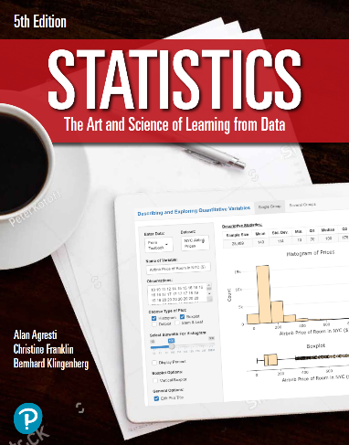

***“Statistics: The Art and Science of Learning from Data”***

**by Agresti, Franklin and Klingenberg, 5th edition**

**Chapter 10**

**Example 14: Reaction Time – Comparing Means for Two Dependent Samples**

## Reading in data

reactionTimesPaired <- read.csv(file='https://raw.githubusercontent.com/artofstat/data/master/Chapter10/paired_reaction_times.csv')

## To compare the means for two dependent samples, you can add the paired = TRUE as another argument for the t.test() function

t.test(reactionTimesPaired$Yes, reactionTimesPaired$No, paired = TRUE)

##   
## Paired t-test  
##   
## data: reactionTimesPaired$Yes and reactionTimesPaired$No  
## t = 5.4563, df = 31, p-value = 5.803e-06  
## alternative hypothesis: true difference in means is not equal to 0  
## 95 percent confidence interval:  
## 31.70186 69.54814  
## sample estimates:  
## mean of the differences   
## 50.625